

|  |
| --- |
| [Version 1.0]  **Last saved by: Charlotte Hutchinson**  **Last saved on:** 15/10/2014 |

|  |
| --- |
| Iteration 2 Plan |
| [Publish Date] |
| **Charlotte Hutchinson**  CO600: JustHealth Supervisor: Yang He |

JustHealth Iteration 2 Plan

# Aims:

* To have a fully functioning Android login screen that connects to the database
* The ability for users to be able to register and log in (Android)
* The login screen does not allow any erroneous data or attacks (Android)
* A 5 times failed login where the user will have to reset their password (Android)
* Once a user has logged in on the web they will be directed to a home screen for either patient or carer

# Requirements:

## 2.1 Functional requirements:

1. Ability to register an account- Android
2. Ability log in to that registered account - Android
3. Ability to reset password- Android
4. A user will be locked out after 5 failed attempts- Android
5. Ability to view home page once logged in for carer/ patient- Web

## 2.2 Non-functional requirements:

1. Accessibility
2. User Documentation
3. Security (Android)
   1. Encryption of passwords and sensitive user information
   2. In-line network security
   3. Physical network security
4. Robustness
   1. Error handling
   2. Security (as above)
5. Ease of Use
   1. Simple and intuitive design
   2. Clear colour scheme

## 2.3 Domain Requirements:

1. Security (Android)
   1. Legal requirements will mean that the sensitive information e.g. password will need to be encrypted.
   2. Terms and conditions accepting on registration
   3. Tick box to acknowledge that data provided is accurate and that it is the responsibility of the user to keep this information up-to-date and is not the responsibility of JustHealth (registration)

# Design

## apploading3.1 Application start-up

* The application start up screen will be the same colour as the logo background (#2272EB)
* The logo will appear across the centre of the screen full width – either just the image, or both image and ‘JustHealth’
* The buffering/loading icon will appear at the bottom (centre) of the screen, spinning.

## 3.2 User log in

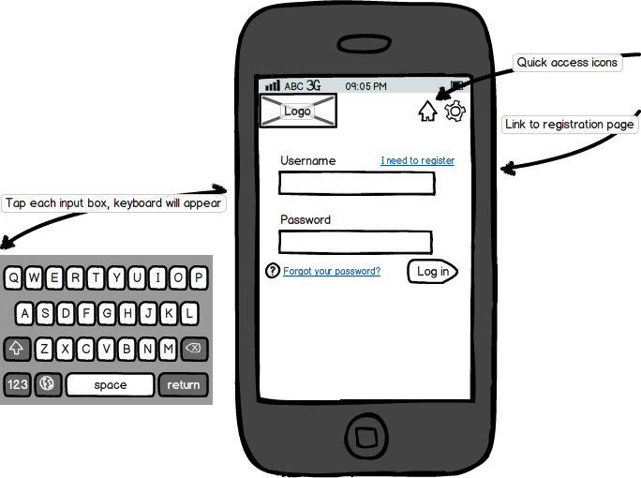

* The JustHealth logo will stay in the upper-left corner of the screen at all times, with the header of the screen based on the colour of the logo background.
* Quick access icons will be the same colour as the JustHealth logo font
* Page backgrounds will all be a shade of light-grey, text fields will be in white with all page content black.
* Buttons will be uniform in size
* Links will be clearly visible
* When the user presses on a text field, the device’s native keyboard will show

## 3.3 Register user

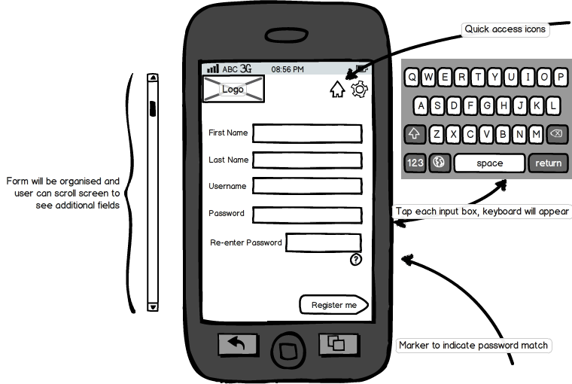

* The form fields must be uniform in size and colour, location on the page will be controlled. The user will be able to scroll to show any additional fields.
* The ‘Register’ button will show at the bottom of the form
* The quick access buttons will stay in the top-right corner
  + ‘Home’ icon will navigate back to log in screen
* When the user presses on a text field, the device’s native keyboard will show

## 3.4 Web home page interface

* Tiles will be colourful and appealing; prioritised and organised on the page
* Tile icons will be centred and clear to the user
* There will be text in the header indicating that the profile belongs to a patient/carer

# 4.0 Use case:

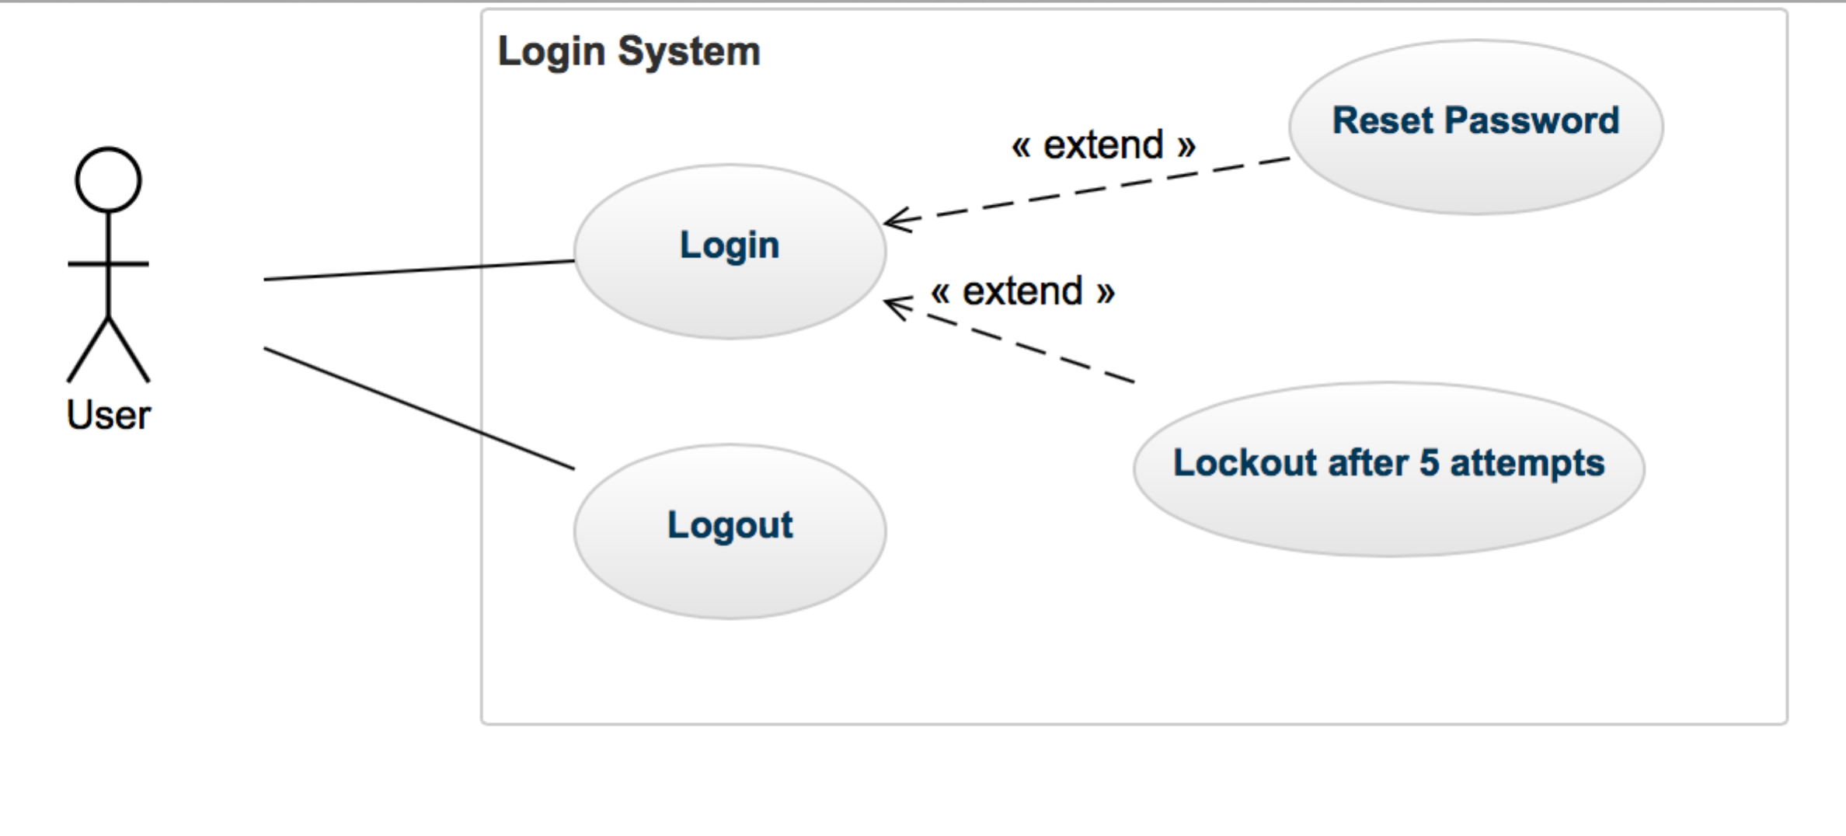

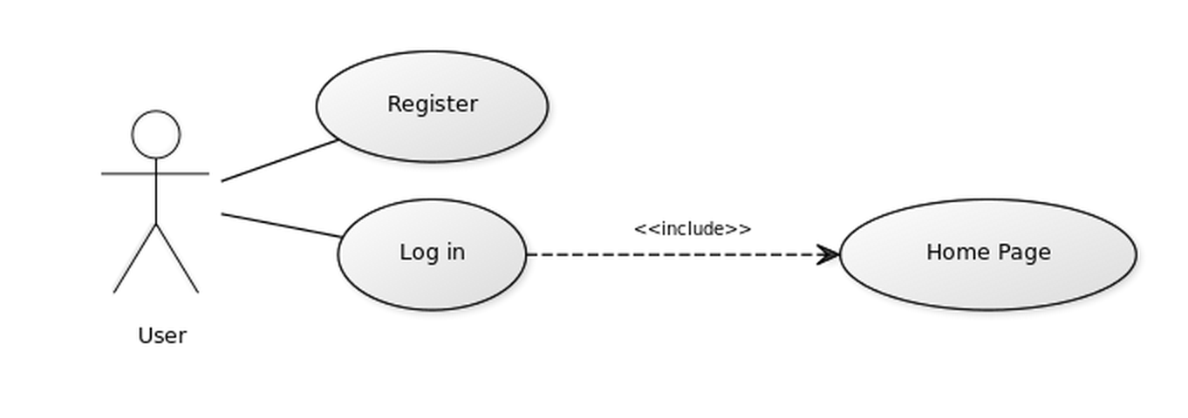

**Registration and log in**